Use this reference to create an EIB (Enterprise Integration Builder).
EIB is a guided and graphical no-code integration tool designed to help institutions extract and transfer mass amounts of Workday data with ease.

Create EIB

- Login into Workday. In the search bar, type “Create EIB”.
- In the Name field, type a descriptive name for the new EIB, select its direction and click “OK”. In this example, the intent is to import data so “inbound” is selected.

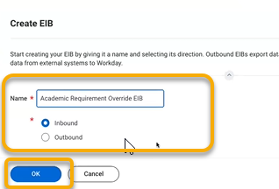

TIP: Before you name the new EIB, check to confirm the name is not already in use. In the Workday search bar, type “Launch / Schedule Integration”. In the Integration field, type keywords describing your new EIB. Existing EIBs with similar keywords will auto-populate. Do not use the name of an existing EIB.

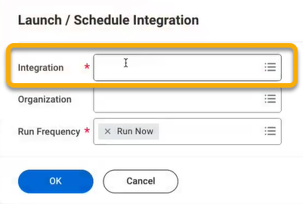

- On the General Settings page, click “Next”.

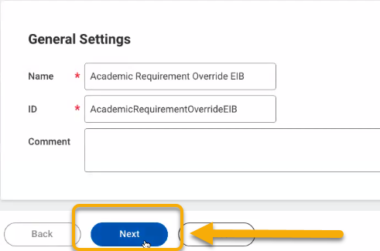

- On the Get Data page, scroll down to the Data Format heading.

- Find the “Web Service Operation” field and type keywords for the operation you are seeking. The field will auto-populate with proposed matches.
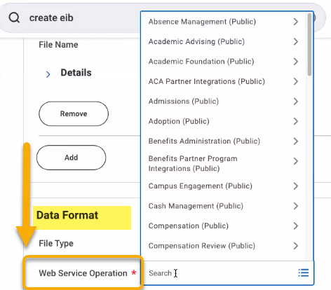
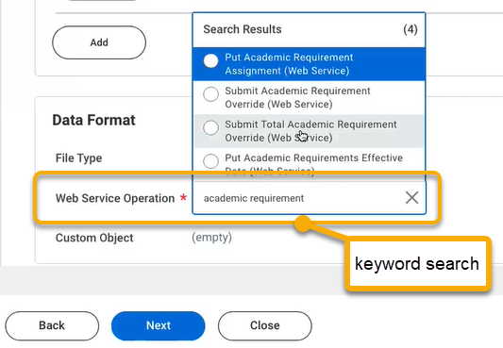

- After review, select a web service operation and click “Next”.

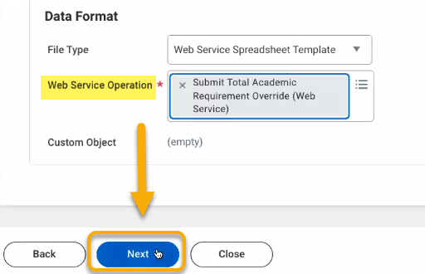

- On the Transform page, click “Next”.

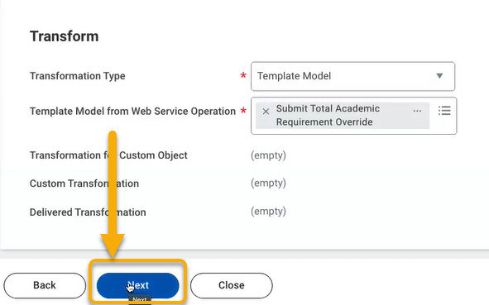

- On the Deliver page, click “Next”.

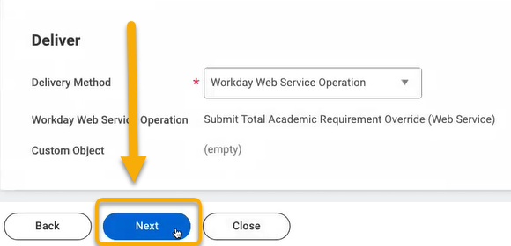

- On the next page, under the Get Data heading, click “OK”.

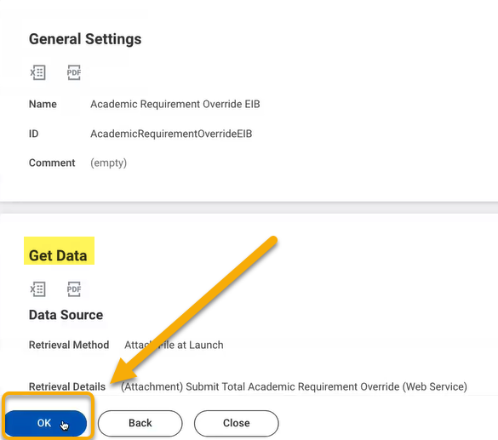

Generate EIB Template

- On the View Integration System page, follow these steps to download a data template:
- Click related actions button to reveal more options,
- Hover over “Template Model”,
- Click “Generate Spreadsheet Template”.

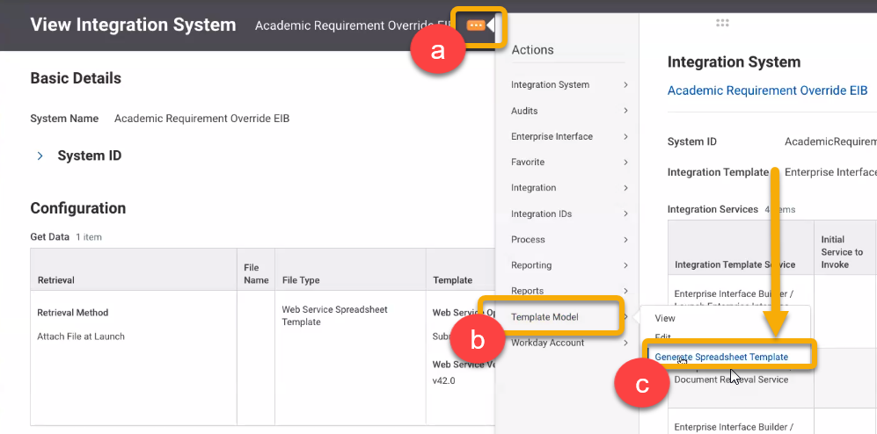
2. The Generate with Data page will open. Click “Submit”.

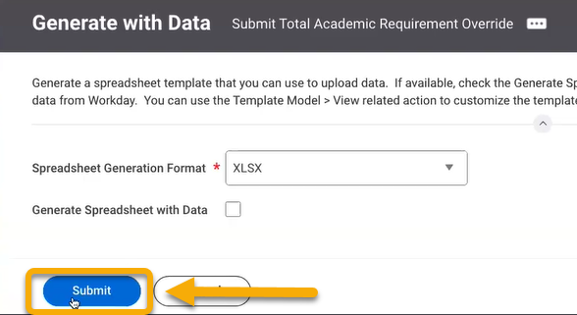

3. On the View Background Process page, click “Refresh”.

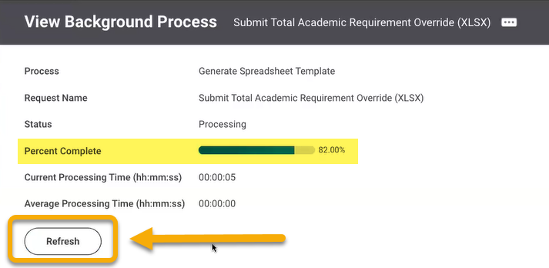

The Percentage Complete bar will show processing. Continue clicking “Refresh” until the button disappears. You will also receive notification of the finished report in the top-right corner of your screen.

4. Click the finished report notification, download, and open.

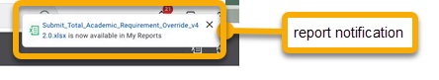

5. The report will download as an excel file. Open and review. Sort the Spreadsheet Key column to organize data in numerical order.

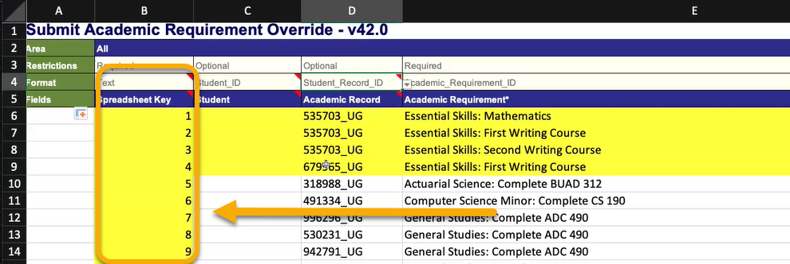

6. Fill the data in to the correct columns.
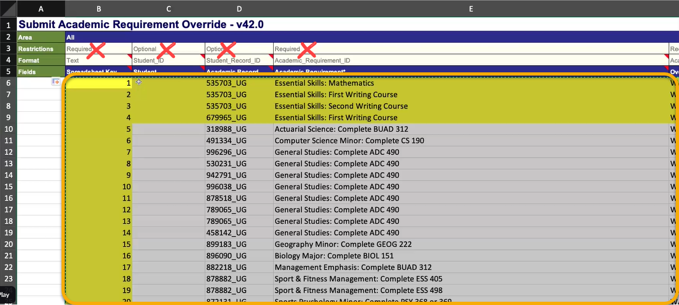

Launch EIB Template

- When report is compiled and complete, upload and integrate into Workday. To do this, search “Launch / Schedule Integration”.

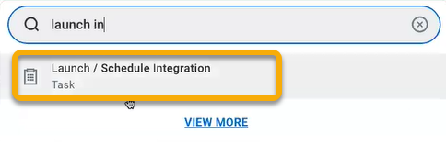

- On the Launch / Schedule Integration page, type the name of the EIB from step 2 into the Integration field. Click “OK”.

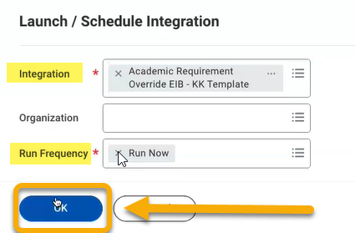
- The Schedule an Integration page will open.

Find the Integration Attachment field and coordinating Value field.

Click the Value field.

Click “Create Integration Attachment”

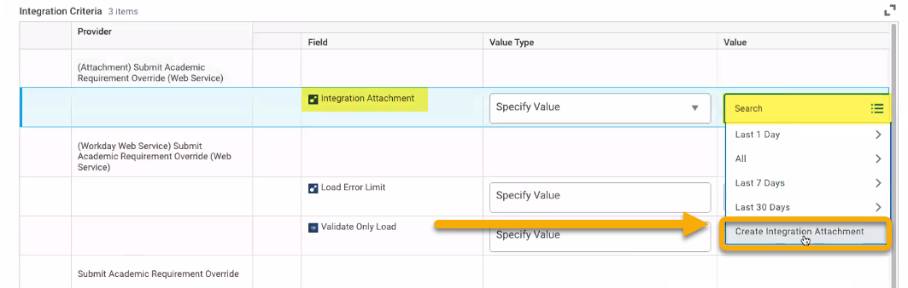

This will prompt you to select and upload the EIB file from your computer. Complete this process and upload.

When successfully uploaded, you will see a confirmation message. Click “OK”.

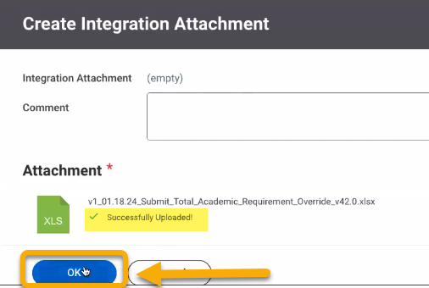

- When the upload process is complete, scroll down and click the Validate Only Load button.

Click “OK”.

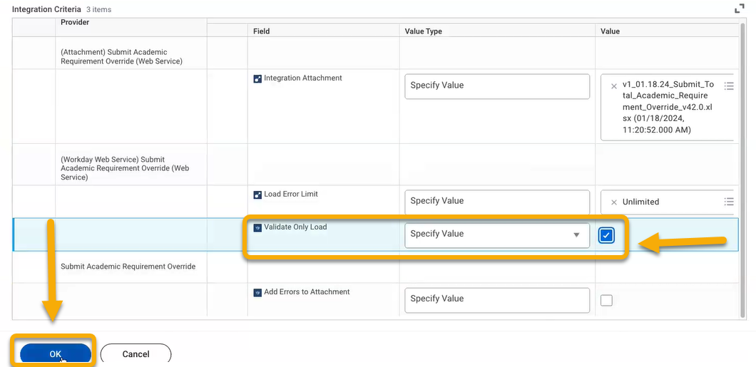

- The View Background Process screen will open. Like before, click “Refresh” until complete.

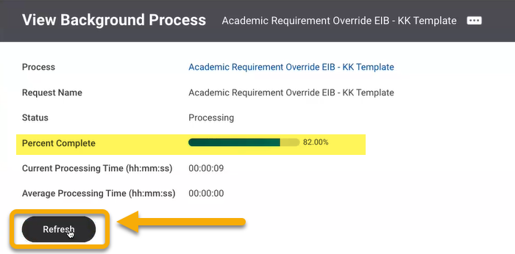

- Once the processing is complete, you may receive the Status: Completed with Errors.
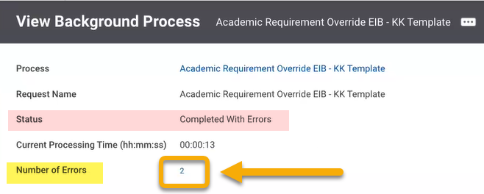

To view the errors, hover over the number in the Number of Errors field.

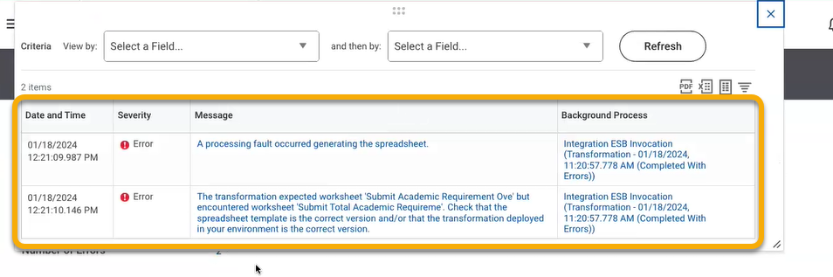

To view error details, click the hyperlinked error message. Use the error details to identify the error and find a solution.

Security for EIBs

To make sure you have the security set up for the EIB, go to

    - Security for Securable Item task
    - Search the name of the web service/integration – Workday’s name
    - Find the item – it will say something like “web service”
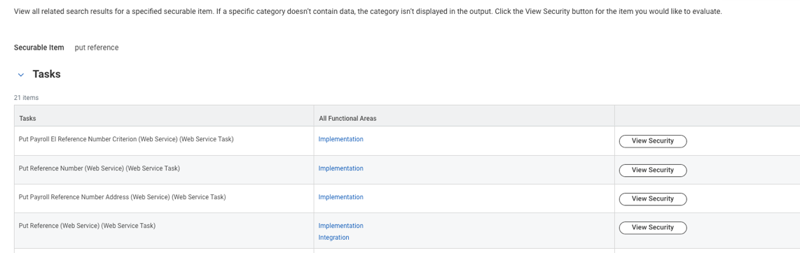
    - Click on the Security Policy to see what it is – not the OX or one that is blank
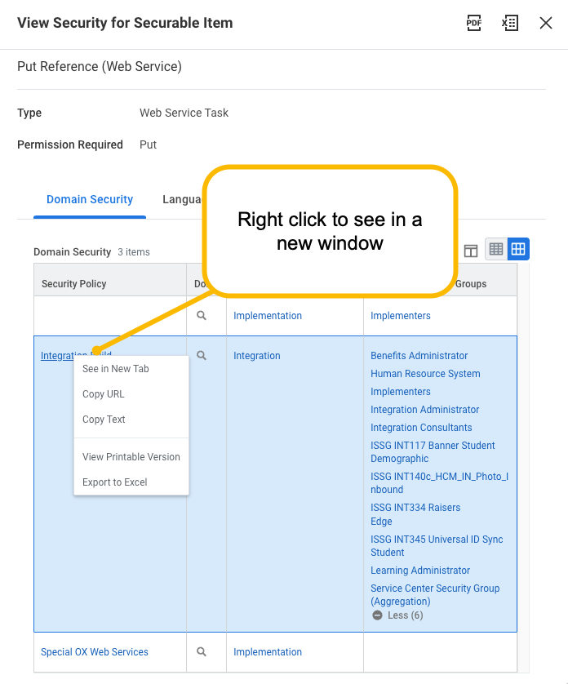
    - Scroll to the bottom. That’s where the “integration” section is. Look to make sure the person that needs to run the EIB has Get and Put security.
